


RESELLER AGREEMENT
Sautech (Pty) Ltd and
Company Name

01st March 2023

CONTENTS
1 PARTIES TO THE AGREEMENT 3
2 EFFECTIVE DATE 3
3 RESELLER PRODUCTS 3
3.1 Hosted Microsoft Exchange 3
3.2 Sentinel One 4
3.3 Spam Titan 4
3.4 Cyber Security and Insurance 4
3.5 Penetration Testing 5
3.6 Virtual Servers 5
3.7 Additional Services 5
3.8 Dedicated Servers 6
3.9 Disaster Recovery & Backups 6
4. PRICING STRUCTURE 7
5 GENERAL TERMS AND CONDITIONS 7
5.1 Support 7
5.2 Record Keeping 7
5.3 Annual Anniversary 8
5.4 Duration of Agreement 8
5.5 Termination 8
5.7 Changes to the Agreement 8
5.8 Invoicing and Payment Terms 9
5.9 Interest for Late Payment 9
5.11 Standard of Care 9
5.12 Assignment 9
5.13 Non-Solicitation 9
5.14 Limitation of Liability 10
6 SIGNATURES 10

PARTIES TO THE AGREEMENT
The reseller agreement (hereinafter referred to as “The Agreement”) is entered by and between
Sautech (Pty Ltd and Reseller Name.

For the The Company

Sautech (Pty) Ltd (hereinafter referred to as “The Company”) with registration number: 2003/006814/07
and having its place of business at 34 Stokroos Avenue, Breaunanda, Krugersdorp, 1739

For the The Reseller

_______________ (hereinafter referred to as “The Reseller”) with Registration Number: 0000/000000/00
and having its place of business at ________________________________________

EFFECTIVE DATE
This reseller agreement will commence on 01st March 2023.

RESELLER PRODUCTS

The company agrees and appoints the reseller and the reseller accepts such appointment as an independent non-exclusive reseller to market, sell, lease and install the following products listed below:

Hosted Microsoft Exchange
- Our Hosted Exchange solution is a fully managed Microsoft Exchange 2016/2019 secure and multi-tenanted solution delivered from the cloud. Our Exchange is supported by Microsoft, Checkpoint Security, Hosting Controller and Spam Titan. This environment is in-house supported by Sautech engineers. Sautech was one of the first to offer Hosted Exchange in South Africa.

Features:

- Always ON
- Calendar Sharing
- Phone/tablet/laptop synchronized email
- Backed-up in the Cloud
- Work anytime, anywhere: always connected, even if your devices are not with you, Webmail access is available
- Up-to-Date: changes made to your email, contacts, and calendars on any device, such as Microsoft Outlook or your smartphone, are kept up to date when accessed via any other device
- Work offline when you travel: work on your email, change contacts, and schedule meetings even while disconnected from the internet.

Sentinel One
- Today’s cyber attackers move fast. Fast enough that 1-10-60 has become an obsolete model for effective detection, investigation, and response. Singularity XDR is the only cybersecurity platform empowering modern enterprises to take autonomous, real-time action with greater visibility of their dynamic attack surface and cross-platform security analytics. Sentinel One is fully managed in house by Sautech.

Features:

- Best in Class Technology
- Industry recognition & results
- Measurable performance advantage
- Key features include: machine learning, real-time forensics, behavioural attack detection, and automated policy-base responses, along with complete visibility into all activity

Spam Titan

- Spam Titan email security is an advanced email protection solution that blocks phishing, ransomware and malicious email threats. Spam Titan offers protection against malware, spear-phishing, advanced persistent threats (APTs), offering insights into new threats to help mitigate risks. Spam Titan Cloud requires no additional hardware or software.

Features:

- Advanced Phishing/Treat/Email Protection
- Proven Spam Solution
- Email Content Filtering
- Security against infected Attachments
- Spam Quarantine Reports
- Outbound Email Scanning
- Whitelisting, Blacklisting & Greylisting

Cyber Security and Insurance

- As the cyber insurance market continues to grow, it’s only natural to discuss its role in the battle against ransomware, which has been a prevalent topic in recent months, and other cyber-attacks. Most discussions highlight its value as a risk mitigation tool and its ability to respond to fast-evolving cyber threats, including ransomware. Recently viewpoints have emerged that cyber insurance has served as an incentive for cyber extortion attacks. The truth is that ransomware attacks occur for one reason only: criminals are succeeding. Cyber insurance can be a valuable tool in the fight against ransomware and other cyber threats. Fulfilling its traditional role, cyber insurance pools the insured that are similarly at risk to spread their potential losses. Sautech has partnered with ITOO Namibia and South Africa to deliver a custom, affordable solution to the market.

The Key requirements for the policy to take effect is:
- Management of infrastructure and insurance devices to enforce compliance and standard
- Sentinel One managed XDR
- Backups within the Sautech Datacenters, encrypted with Sautech’s Standards and Procedures.
- Backups that run daily and at most with a 7-day retention period.

Penetration Testing

- A penetration test, also known as a pen test, is a simulated cyber-attack against your computer system to check for exploitable vulnerabilities.

Penetration Testing Stages:
- Management of infrastructure and insurance devices to enforce compliance and standard
- Planning & Reconnaissance
- Scanning
- Gaining access
- Maintaining access
- Analysis and WAF Configuration

Penetration Testing Method:
- External testing
- Internal testing
- Blind testing
- Double-blind testing
- Targeted testing

Penetration Testing Phases:
- Pre-engagement: Define scope, documentation and rules
- Engagement: Evaluate application and/or network layers along with segmentation
- Post-engagement: Findings and insights which are applicable and useful.

Virtual Servers

- VPS is your own virtual private server. Working with virtual servers is the same as dedicated servers. All access and connectivity are managed by Sautech and access to servers are on the same basis as dedicated infrastructure. VPS gives you computing resources at a lower price when compared to dedicated servers. The flexibility to upgrade resources are easily managed and can be up or down scaled at any time.
- Sautech provides the virtual infrastructure hardware and allows you to choose your preferred operating system i.e. Microsoft Windows or Linux Distros.
- VPS hosting enables you to build your own web hosting company, file server, application hosting services and solutions on top of our tiered Dell infrastructure hosted throughout Southern Africa.
- Additional services can be installed and configured as tailor made packages. We offer self-managed and managed solutions.

Additional Services

- Windows Server 2022
- vCPU
- vRam
- vHDD SATA
- vHDD SDD
- Sentinel One Server
- Veeam Base License
- Server Support/ Management
- Static IP Address
- Hyper-V Rep Na-RSA 250GB
- Hyper-V Rep Na-RSA 500GB
- Hyper-V Rep Na-RSA 1TB
- Hyper-V Rep Na-RSA 2TB
- Backups per GB
- Remote Desktop per user

Dedicated Servers

- Powerful performance, since physical servers are designated to a single client and do not share processors or other components with other users, they deliver greater performance. With physical servers, you won't experience lags even during peak times.
- Sautech offers dedicated hardware rental. We have various models and configuration of 1U and 2U Dell servers available either on a fixed term or month to month basis (depending on the specifications).All our servers are dual power supply running from different power feeds for reliable power distribution and uptime.

Dell Server:
- Entry level Dell
- 64 GB memory
- 2 x Xeon CPU
- 8TB SATA

Disaster Recovery & Backups

- You might need to restore backup data if you encounter an accidental deletion, database corruption, or problem with a software upgrade. Disaster recovery, on the other hand, refers to the plan and processes for quickly re-establishing access to applications, data, and IT resources after an outage.
- The purpose of the backup is to create a copy of data that can be recovered in the event of a primary data failure. Primary data failures can be the result of hardware or software failure, data corruption, or a human-caused event, such as a malicious attack (virus or malware), or accidental deletion of data.
- Sautech operates on either VMWare or Hyper-V and have multiple datacentres.
- We offer replication and DR services between South Africa and Namibia.
- Backup services can also be hosted within our MPLS network in either of the above-mentioned countries.
- Our Services are provided using either Veeam or Hyper-V Microsoft Services.
- Our storage solution is built upon Synology Hyper-Backup

4. PRICING STRUCTURE
All fees and expenses for the reseller set out below:
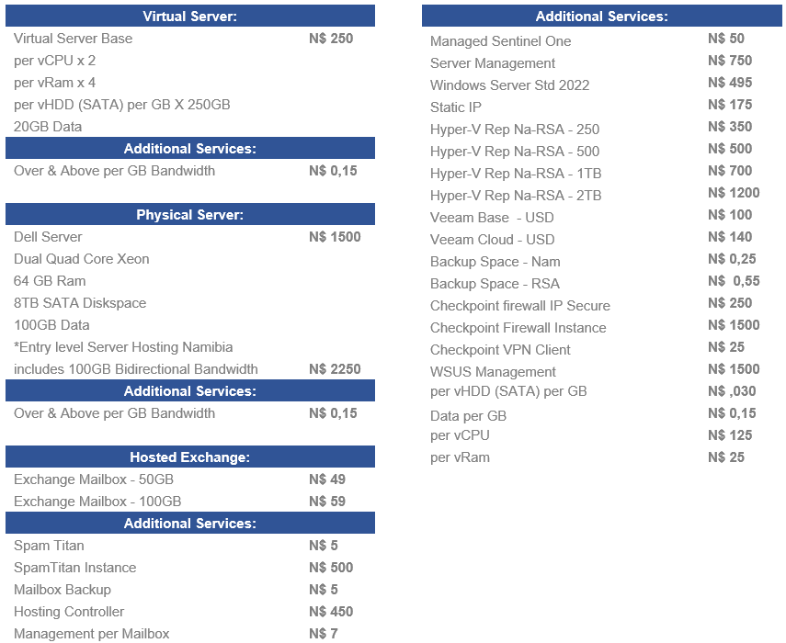
*All prices exclude VAT

5 GENERAL TERMS AND CONDITIONS
All support and services are subject to the company’s standard terms and conditions and the reseller will fall under the company’s service level agreements.

5.1 Support
The reseller will be responsible to support the reseller’s own client. The company will provide the necessary training services and backup support where applicable and agreed to in advance.

5.2 Record Keeping
The reseller shall maintain adequate books and records in connection with its activities. Such records shall include invoicing, payment and other financial records associated with each transaction.

5.3 Annual Anniversary
The annual anniversary is 28 February of each calendar year following the next business year of this agreement. On this date, the fee structures in this agreement will be incremented with a standard rate related to the annual released CPIX rate if applicable to the specific service or services. Before this takes effect, all services will be discussed and agreed upon in writing between the company and the reseller. .

5.4 Duration of Agreement
This agreement will be on a month to month basis after signoff, and is automatically renewable for a further month at the end of this initial period and on each subsequent anniversary of the commencement date.

5.5 Termination
Either party may terminate this agreement at any time, providing 30 days written notice is received to terminate the agreement by either party.
In the event of termination of this agreement for any cause, the company will continue to be paid up to the effective date of termination for any fees or expenses due for services delivered up to that date.

5.6 Destruction of Data and Records or Return on Termination
Upon termination of this agreement, the receiving party, at the option of the disclosing party, will return all confidential information belonging to the other party.

5.7 Changes to the Agreement
All changes to this agreement must be approved in writing by authorised officials of both parties. No change to this agreement will be honoured unless reduced to writing and signed by all parties to this agreement
To initiate a contract change, the following procedure shall be adopted:
- the requestor prepares a request in collaboration with the other party, which shall contain or have attached all information necessary to enable the recipient of the request to consider the request and reach an informed conclusion, but at least the following information;
- a description of the requested contract change;
- the reason for the contract change;
- suggested new or amended wording to the agreement or the service orders in question;
- suggested plan for the implementation of the contract change, if applicable;
- implementation roles and responsibilities;
- cost implications;
- impact analysis.
- the requestor will submit the request to the appropriate authorised person at the other party as may be determined from time to time.
- the recipient of the request shall within a reasonable time review the request. If necessary, the request will be debated and/or negotiated at a meeting scheduled between the parties for purposes of the request.
- if the contract change is not accepted, it shall be confirmed in writing to the other party.
- if the initial persons from the respective parties are unable to agree on a proposed contract change, the matter may be escalated to the parties’ respective executives.
- If the contract change is rejected, the receiving party shall provide to the requesting party in writing, within 5 (five) business days, the reasons for rejecting the requested contract change request, whereupon the requesting party may submit a revised contract change request which considers the receiving party's reasons for rejecting the initial contract change request.

No change to this agreement will be honoured unless reduced to writing and signed by all parties to this agreement.

5.8 Invoicing and Payment Terms
The company will submit invoices to the reseller for fees in advance and agreed reimbursable expenses in arrears on a monthly basis. Each invoice will clearly state the work performed, hours worked and reimbursable expenses incurred.
All fees and expenses are to be paid to the company, by Internet transfer of funds to the account designated by the company. All invoices are payable within 30(thirty) days from the receipt of the invoice. Any amounts disputed in good faith may be deducted from the invoice and the remainder must be paid by the due date. The disputed amount should be notified in writing to the company within 7(seven) days of receipt of the invoice giving the reasons for withholding payment. Upon receipt of the reseller’s dispute notice, the company and the reseller will work together in good faith to resolve such disputes in a prompt and mutually acceptable manner. The reseller agrees to pay any disputed amounts within 5(five) days once the issues have been resolved. Should the dispute not be resolved in the aforesaid manner, then it shall be resolved by way of arbitration in accordance with the provisions

5.9 Interest for Late Payment
Any undisputed amount due by either party whether in terms of this clause or any other clause of the agreement, which is not paid on due date shall attract interest at prime rate percentage points, calculated 15 (fifteen) days after the specified due date of such undisputed amount until the date of payment, both days inclusive, compounded monthly.

5.10 Destruction of Data and Records or Return on Termination
Upon termination of this agreement, the receiving party, at the option of the disclosing party, will return all confidential information belonging to the other party.

5.11 Standard of Care
Each party will act in good faith in the performance of its respective duties and responsibilities and will not unreasonably delay or withhold the giving of consent or approval required for the other party under this agreement. Each party will provide an acceptable standard of care in its dealings with the other party and its employees.

5.12 Assignment
Neither party may assign or otherwise transfer this agreement without the prior written consent of the other party. In the event that consent for assignment is given, the terms of this Agreement will be binding upon each party’s respective successor.

5.13 Non-Solicitation
During the term of this agreement and for two years after its expiration or termination, neither party will solicit any employee of the other party for the purposes of offering employment.

5.14 Limitation of Liability
The company is not responsible for any damages caused by the failure of the reseller or its Affiliates or other suppliers to perform their responsibilities.
Neither party shall be liable to the other party, whether in terms of any indemnity or otherwise, for any loss or damage that such other party may suffer, to the extent that such loss or damage arises in whole or in part from any act or omission of the other party or its affiliates.
Notwithstanding any provision to the contrary in this agreement, the aggregate liability of the company to the reseller in respect of all claims for damages, causes of actions and occurrences arsing under this agreement, or any of the service schedule forming part hereof, arising during each contract year shall be limited to 12 (twelve) months fees as set out under this agreement, subject to gross negligence or wilful misconduct and loss due to that.
Neither party shall be liable to the other for a) any special or indirect damages whether within the contemplation of the parties or not and / or b) loss of income or profit, howsoever arising, unless such losses or damages are the direct result of a party’s gross negligence or wilful misconduct.
The parties shall keep each other fully and effectively indemnified against injury or death due to the negligent or wilful acts or omissions by such party or its employees or agents acting in the course of their employment pursuant to this agreement.

6 SIGNATURES

The following authorised representatives of each party execute this agreement at the commencement date:
01st March 2023.

For the Company

Signature: ______________________________
Name: Riaan van Jaarsveld
Position: Director
Date of Signing: 01st March 2023
Place of Signature: Krugersdorp

For the Reseller

Signature: ______________________________
Name: ______________________________
Position: ______________________________
Date of Signing: ______________________________
Place of Signature: ______________________________

